Meeting with Huntsville Disc Golf Club and the Town of Huntsville

December 6th, 10:00am

Attendees:
HDGC: Peter Ewald, Craig Nakamoto, Mica Streeter
Town of Huntsville: Simone Babineau, Tarmo Uukkivi, Trish Conley-Knight, Tina Scott-Burns

Agenda:
- High level update on the Club and course usage growth – see at end of document.
- Review of Signage plan
  - Club has been working with Trish/Tina/Coleen for over a year and all signage proofs have been approved by Town
  - Club fundraising
    - Money Raised and commitments to sponsors made
      - for 2022 but had to delay and push to 2023
  - Deposit (non refundable) paid to designer
    - Balance due ASAP
  - Sign Breakdown
    - Main course sign
      - Town provides structure
      - Club provides signage – Map
      - Need room for sponsors
    - Tee Signs
      - Short Tee
      - Long Tee
      - Each with Sponsor
      - Town provides C Channel for Posts X 36
- Next Steps:
  - Confirm Town Commitments
    - U Channel for Tee Signs
      - Directed to order
        - Lead time - will review with Tina when order is completed
    - Structure for Main Course Sign
      - Make to match Soccer club sign
        - Tina to go ahead to get installer/supply quotes.
      - Design is done of the actual sign
        - Send specs to Tina with Dimensions
  - Order Locates now so we are ready for Spring
    - Done with G Tel/other at the same time as we mark the locations and when U channel is in.
      - Tina to book when U Channel is in.
  - Maintenance Agreement/MOU
    - See below

- MOU
  - December 12th structure meeting will dictate the MOU
  - ToH send to HDGC for review when ready
  - Use Bracebridge as an example
  - Challenge: Colleen not available
  - Questions:
    - Insurance
      - HDGC has insurance and will provide updated COI in the new year
    - Maintennace level
      - HDGC:
        - General upkeep – landscaping work with hand and power tools
        - Signage management
        - Sponsor management
      - Town continues to do the regular maintenance
        - Grass
        - Bridges
        - Etc.
    - Risk Management
    - Term – standard municipal language
      - Suggest we meet annually for quick review
        - Updated stats
        - Make sure no issues
      - Start one year with renew for 4-year term.
- Budget
  - Community Services/Parks/Users
  - Meets requirements
  - Use Parks budget
Actions:
- Town of Huntsville – Order 36 x U Channel (6 or 8 feet) immediately
- HDGC – order signs immediately
- Town of Huntsville – Investogate Main sign design to match Soccer sign and share with HDGC immediately
- HDGC – Send dimensions of Main Course sign to Tina immediately
- Town of Huntsville – Get quotes for Main course sign – based on item 3 and 4 above.
- HDGC – Add www.huntsville.ca to Town Logo at Main course sign before print
- Town of Huntsville – Create MOU for review by HDGC
  - Timeline – Tarmo please provide a date since we did not discuss the timeline.
- HDGC – when signs are in - meet on site with Tina to review installation
- Town of Huntsville – Book locates after step 8

Course Stats:
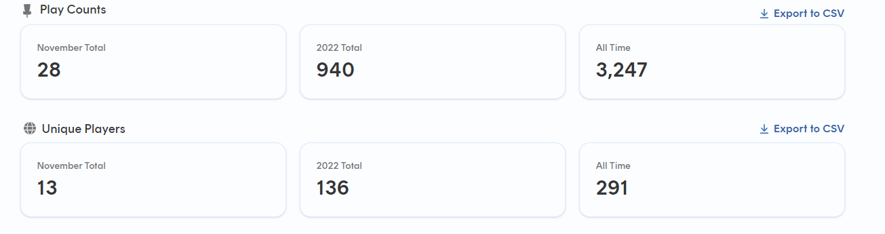
Note: this is only people using the UDisc APP, we estimate this represents 50-60% or users so the actual numbers are much higher.

Club League Stats:
- The Huntsville Disc Golf Club ran our League events weekly this spring/summer/fall
  - Regularly had 12-20 people, including all ages (kids to seniors) men and women.
  - Rented the course and paid the Town of Huntsville $423.75

Club Volunteer Work:
- Did 2 course clean events removing down sticks, brush, and garbage (Spring and Fall)
- Moved former hole 10 basket (which was flooded and unplayable) to new location between former hole 16 and 17
- Moved hole 11 basket to new location for course improvement and better flow on course
- Moved hole 6 basket to new location to deal with flooding.
- Worked with Town staff – Huge Thank you to Tina – to get wood chips in key wet areas for water control and improved aesthetics.

