Huntsville Disc Golf Club
Board Meeting Agenda/Minutes
November 8th, 2022
Invitees:
Nate Kaye
Micah Streeter - Absent
Scott Luttrell - Absent
Craig Nakamoto
Dave Caplan - Absent
Peter Ewald
Justin Murphy - Absent

Agenda:
- Review last meeting action items. Results of Survey:
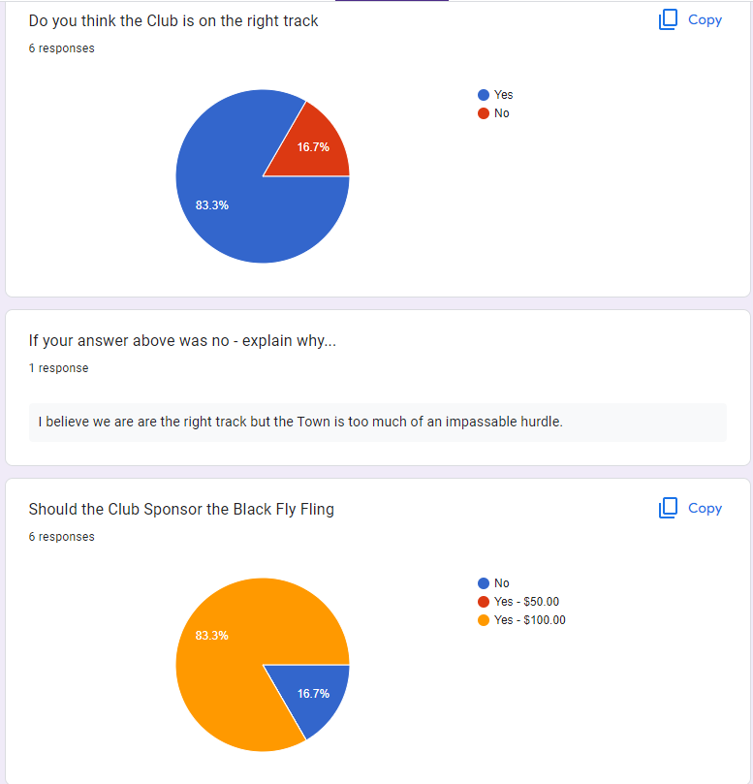
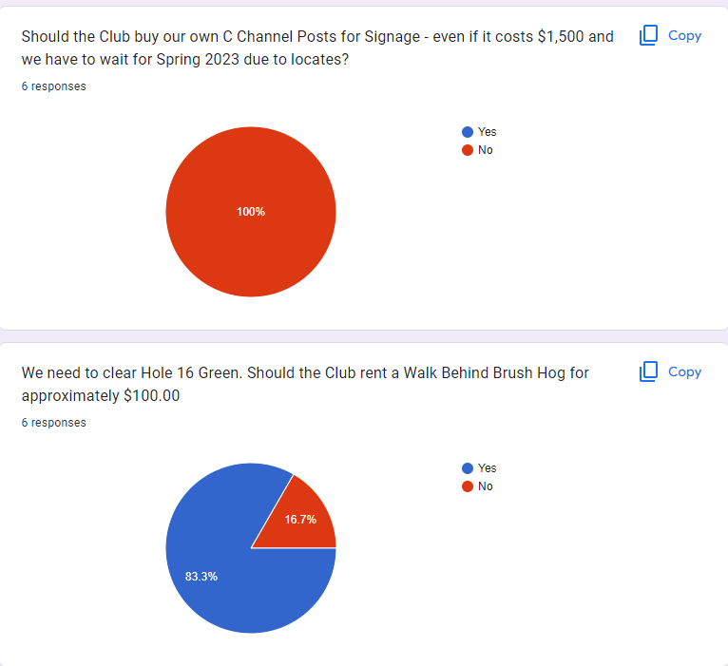
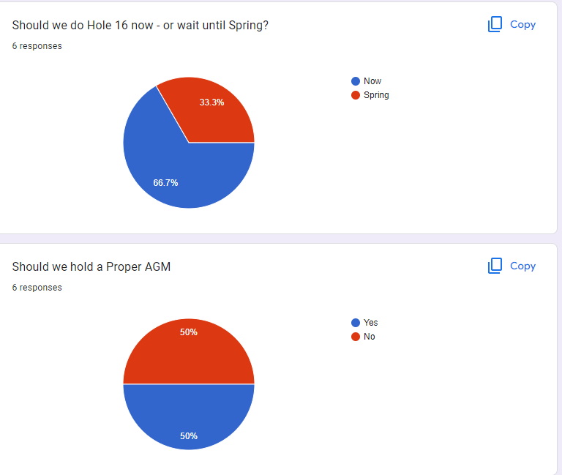
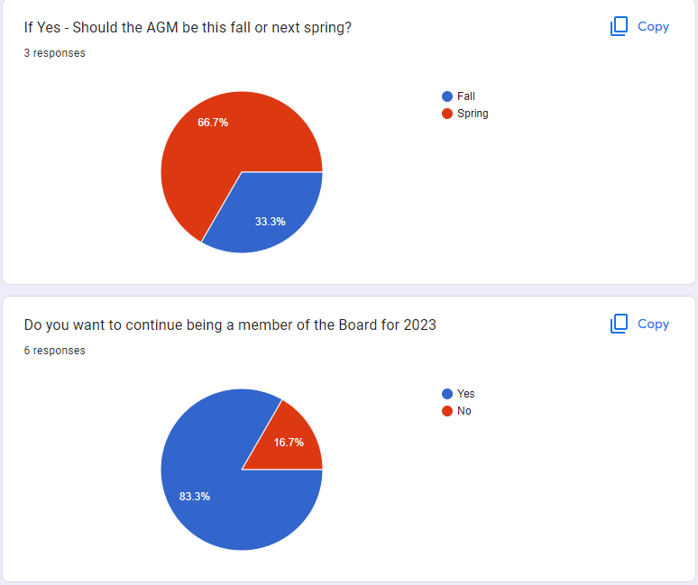

- Signage: Meeting with Town on December 6th to finalize spring plans
  - Craig and Peter to attend and Peter to send invite to Craig
- Finance Update: See below
- New hole 16: See below

Committee Updates
  - Finance (Peter Ewald, Craig Nakamoto, Micah Streeter, Dave Caplan) BALANCE = $4526.88
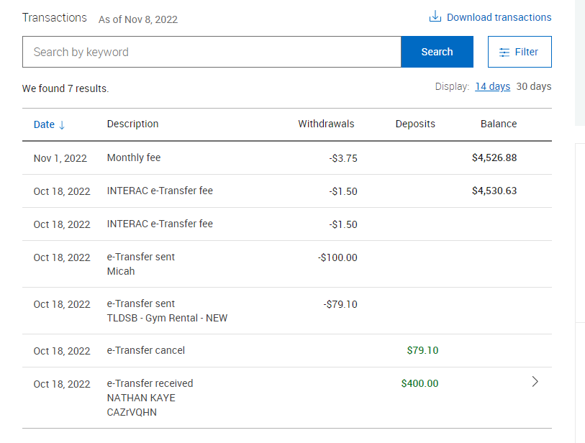
- Putting league: we have paid – $79.10 to school Board for 2021/2022
- Black Fly Fling Sponsorship: we have paid - $100 to Micah
- Owe Town of Huntsville = $423.75 for summer league course rental
  - Peter to arrange payment this week.
- Received $270 from Julien (Already received $500 mid season) from League.
- Nathan has some cash from Putting league 2021/2022
  - Fundraising (Short- and long-term revenue streams for the club), (Nate Kaye, Julien Rogers)
    - T sign Sponsorship
      - $5,000.00 pledged to date
        - 9 X level 1
        - 3 x Level 2
      - Holes assignment – First come first serve
      - Share google sheet with everyone - Done
    - Tags/Membership drive
      - 21 Tags sold
      - Made $511.23 minus cost of $210.00 = revenue of $301.23
        - But we gave out stickers and hats and discs as prizes
          - Not sure the cost of that, stickers and hats were bought by Peter, disc were mostly donated?

  - Events (League, Tournaments, Youth Engagement) (Micah Streeter, Nate Kaye, Julien Rogers)
    - Summer League
      - Completed
      - Town Agreement/Rental – Payment Due $423.75
      - Next year plans/ideas?
    - Winter – putting league – Nate Kaye
      - 2022/2023 – December to March
      - At a Huntsville Gym – Spruce Glen
        - Quoted - $395.00 from School Board
        - Starts December 7th – Wednesdays 7-8pm
        - Craig to put on Website.

  - Infrastructure (Peter Ewald, Dave Caplan, Micah Streeter)
    - New hole 16
        - Use our own saws
        - Craig and Nate – go mid week – Wednesday November 16th, 11:00am-1:00pm
        - Peter to talk to Tina
          - Leave basket outside shop
    - Signage
      - Meeting with Town December 6th at 10:00am
        - Who wants to join – Zoom Call
    - Total Cost – 50% Deposit ($1,965.36) paid to Fluent Disc Golf- Should have proofs in one week.
        - Base Package $3033
          - Standard welcome sign (60x36)
          - Standard T Signs (12x9) x 36
        - Basic Sponsor Signs $900
          - (5x5) x 36
        - Caution Signs $165
          - X3
        - Total = 3930.72
        - Wait untill after Dec 6th meeting with town to pay balance to Fluent
      - Sponsorship package
        - We need more…. Everyone to reach to potentials

  - Membership (Growth, By-Laws, Elections, social media (website and Instagram (Julien Rogers, Peter Ewald, Craig Nakamoto)
    - Memberships package/tags 2023
      - New ideas?
    - Disc with Logo for promotion.
      - INNOVA BEST OPTIONS – PARK FOR NOW.

ACTION ITEMS:
- Send logos to Craig for website
- Craig and Peter to attend meeting with ToH on December 6th at 10:00 and Peter to send invite to Craig
- Putting League
  - Craig to put on Website.
  - Nate to make post on Facebook soon
- Hole 16:
  - Craig and Nate – go mid week – Wednesday November 16th, 11:00am-1:00pm
  - Peter to talk to Tina
    - Leave basket outside shop
- Peter to Update Kevin regarding signage timeline.

