Huntsville Disc Golf Club
Board Meeting Agenda/Minutes
July 5th, 2022
Invitees:
Nate Kaye
Micah Streeter
Scott Luttrell - Absent
Craig Nakamoto - Absent
Dave Caplan - Absent
Peter Ewald
Justin Murphy

Agenda:
- Review last meeting action items.
- Everybody – Reach out to sponsors – In progress
- Peter – Maintenance agreement – Meeting with Town on June 14th at 4:00pm – Craig and Peter - COMPLETED
- Nate – Final invoice from School Board for putting league – Peter to follow up with Nate – Waiting for invoice from school board
- Social media posts for Sponsors – Peter – PENDING Signage finalization
- Everyone to get more sponsors
- Custom stamped Discs – Peter contact Dale at Top Link – Park for now….
- Confirm new Hole 10 Layout (Long Tee), New Hole 16 Layout (Tee and Basket) and New Basket Location Hole 1 - COMPLETED

Committee Updates
  - Finance (Peter Ewald, Craig Nakamoto, Micah Streeter, Dave Caplan) BALANCE = $3595.27
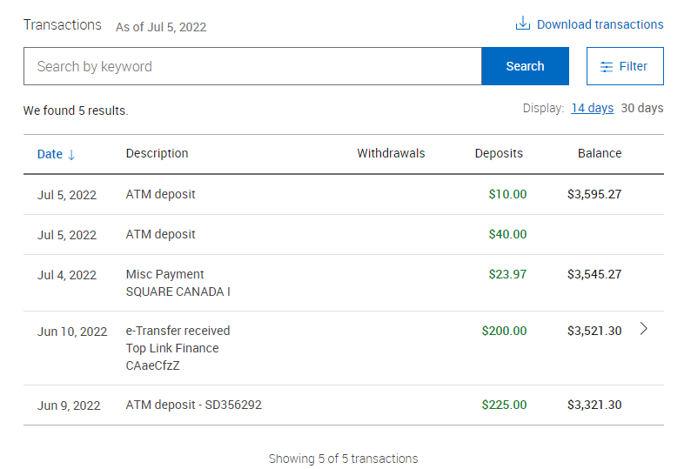

- We need to pay for Putting League – Approximately $200.
  - Revenue was approximately $150.00
  - Fundraising (Short- and long-term revenue streams for the club), (Nate Kaye, Julien Rogers)
    - T sign Sponsorship
      - $4,800.00 pledged to date
        - 9 X level 1
        - 3 x Level 2
      - Holes assignment – First come first serve
      - Share google sheet with everyone - Done
    - Tags/Membership drive
      - 19 Tags sold

  - Events (League, Tournaments, Youth Engagement) (Micah Streeter, Nate Kaye, Julien Rogers)
    - Summer League
      - Going Well
      - Town Agreement/Rental – Done
      - Discussion - Need discs?….or just Cash prizes?
        - Cash for now
      - $5 bucks – plus $2 CTP
      - Continue conversation next meeting

  - Infrastructure (Peter Ewald, Dave Caplan, Micah Streeter)
    - NEW hole 10 – needs a better long tee pad – move to right and up a bit
      - COMPLETED
    - Flag new hole 16
        - COMPLETD
REQUIRES A LOT OF TRIMMING – WAIT UNTILL FALL
    - Hole 1 Basket
      - Not the best for Hole 1B
      - SUREVY COMPLETED AT LEAGUE
    - Signage
    - Total Cost – 50% Deposit ($1,965.36) paid to Fluent Disc Golf- Should have proofs in one week.
        - Base Package $3033
          - Standard welcome sign (60x36)
          - Standard T Signs (12x9) x 36
        - Basic Sponsor Signs $900
          - (5x5) x 36
        - Caution Signs $165
          - X3
        - Total = 3930.72
      - Sponsorship package
        - We need more…. Everyone to reach to potentials

  - Membership (Growth, By-Laws, Elections, social media (website and Instagram (Julien Rogers, Peter Ewald, Craig Nakamoto)
    - Memberships package/tags
      - We need to encourage more sales
    - Disc with Logo for promotion.
      - INNOVA BEST OPTIONS – PARK FOR NOW.
        - Peter to email Dale

- Clothing
    - ORDERS READY ON FRIDAY!
Website Closed
      - Only received 9 orders
        - Two for the club
          - 50 Stickers
          - 10 Hats
      - All orders now going to production – Expected end of June
      - All Members get stickers the rest sell for $3.00 or use for prizes
      - Extra 10 hats ordered for Club Sales
        - Sell at $30.00
        - Or use for Prizes

ACTION ITEMS:

