Huntsville Disc Golf Club
Board Meeting Agenda/Minutes
May 3rd, 2022
Invitees:
Nate Kaye
Micah Streeter - Absent
Scott Luttrell - Absent
Craig Nakamoto
Dave Caplan - Absent
Peter Ewald
Justin Murphy - Absent

Agenda:
- Review last meeting action items.
• Peter to updated clothing with Portage Promotions
• Craig to contact Home Depot and Rolstons for T sign post
Paused for now – due to Town of Huntsville
• Peter to create one page sponsorship package flyer
Done
• Everyone to reach out to potential sponsors
In progress
• Micah to talk to Top link re: discs for league
Pending
• Justin and Peter to arrange payment to tag guy
Done
• Nate and Peter to arrange payment to School board
Waiting for final invoice
• Peter to do social media post for membership/tags
Done
• Peter to follow up with Colleen at TOH
Done
• Peter to follow up with Fluent
Done
- Committee Updates
  - Finance (Peter Ewald, Craig Nakamoto, Micah Streeter, Dave Caplan) BALANCE = $948.19
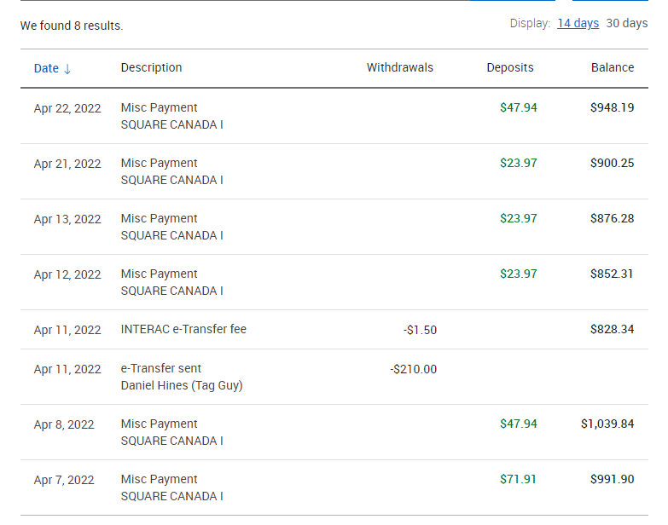

- We need to pay for Putting League – Approximately $200.
  - Revenue was approximately $150.00
  - Fundraising (Short- and long-term revenue streams for the club), (Nate Kaye, Julien Rogers)
    - T sign Sponsorship
      - $1400.00 pledged to date
        - 2 X level 1
        - 1 x Level 2
      - Holes assignment – First come first serve
      - Share google sheet with everyone
    - Tags/Membership drive
      - 14 Tags sold – I am fairly sure….Need to ask Julien for update

  - Events (League, Tournaments, Youth Engagement) (Micah Streeter, Nate Kaye, Julien Rogers)
    - Summer League
      - Unofficial pre-season going well
      - Official Start Date - Wed June 1st
      - Town Agreement/Rental – with Peter
      - Discussion - Need discs?….or just Cash prizes?
        - With Micah to talk to TopLink
      - $5 bucks – plus $2 Ace Pot
      - Continue conversation next meeting

  - Infrastructure (Peter Ewald, Dave Caplan, Micah Streeter)
    - Spring Course Clean Day / Move Baskets
      - Sunday May 15th….
    - Signage
      - Total Cost
        - Base Package $3033
          - Standard welcome sign (60x36)
          - Standard T Signs (12x9) x 36
        - Basic Sponsor Signs $900
          - (5x5) x 36
        - Caution Signs $165
          - X3
        - Arrows $270
          - x 18
        - Total = 4368 +Tax = $4935.84
      - Sponsorship package
        - We need more…. Everyone to reach to potentials
      - Craig to call Home Depot and Rolstons

  - Membership (Growth, By-Laws, Elections, social media (website and Instagram (Julien Rogers, Peter Ewald, Craig Nakamoto)
    - Memberships package/tags
      - We need to encourage more sales

- Clothing
    - Website Live
      - Any questions?

ACTION ITEMS:
- Peter - Share google sheet with everyone
- Craig – Put sponsorship on Website and payment link for both levels
- Everybody – Reach out to sponsors
- Peter – Maintenance agreement
- Micah – Reach out to TopLink
- Nate – Final invoice from School Board for putting league
- Peter – Make post about Course Clean up day – Sunday May 15th

