Huntsville Disc Golf Club
Board Meeting Agenda/Minutes
April 5th, 2022
Invitees:
Nate Kaye
Micah Streeter - Absent
Scott Luttrell
Craig Nakamoto
Dave Caplan - Absent
Peter Ewald
Justin Murphy

Agenda:
- Review last meeting action items.
  - Peter – Ask Julien re: running league
  - Nate – Start formulating plan for sponsorship

- Committee Updates
  - Finance (Peter Ewald, Craig Nakamoto, Micah Streeter, Dave Caplan) BALANCE = $919.99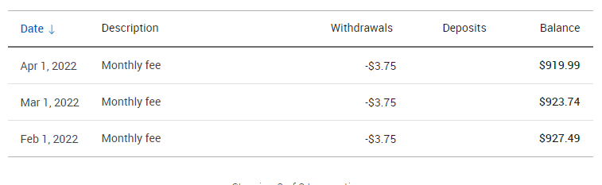
- We need to pay for Putting League – Approximately $200.
  - Revenue was approximately $150.00
- We need to pay for tags
  - $7x30=$210.00

  - Fundraising (Short- and long-term revenue streams for the club), (Nate Kaye, Julien Rogers)
    - T sign Sponsorship
    - Tags/Membership drive
  - Events (League, Tournaments, Youth Engagement) (Micah Streeter, Nate Kaye, Julien Rogers)
    - Summer League – Julien will run
      - Unofficial pre-season starting this week.
      - Official Start Date? Potential early June officially (Wed June 1st)
      - Town Agreement/Rental – with Peter
      - Discussion - Need discs?….or just Cash prizes?
        - Extra dollar for CTP?
        - Or club merch?
      - $5 bucks – plus $2 Ace Pot
      - Continue conversation next meeting

  - Infrastructure (Peter Ewald, Dave Caplan, Micah Streeter)
    - Spring Course Clean Day / Move Baskets
      - Earlier May?
    - Signage
      - Sponsorship package
        - Put together one page and contract
          - Two levels
            - Small signs - $200 minimum
              - 3 years
            - Platinum level - $1000 minimum
              - 5 years
        - What do they get in return?
          - Sign
          - Website
          - Facebook
        - Use course stats and Facebook stats
      - Craig to call Home Depot and Rolstons

  - Membership (Growth, By-Laws, Elections, social media (website and Instagram (Julien Rogers, Peter Ewald, Craig Nakamoto)
    - Memberships packages
    - Different levels – One with all the goodies and one basic.
      - One Level includes - $25
        - Sticker
        - Bag Tag
          - Justin ordered and done.
            - Cost - $7 each
            - Number – 30
        - Ace Pot – Whole if member, half if not a member
      - Discs?
        - Minis?
          - Nate talk to Ryan and Micah
          - Minimum 50?

- Clothing
  - Add White and Black to T Shirts
  - Add one more colour to Hoodie - Grey
  - Volume discount – Peter asks Beth
  - Dri-Fit T shirt instead of Polo
  - Pricing
    - T shirt - $25
    - Hoodie - $60
    - Stickers - $2.50
      - Club buys – 100
    - Hats - $25

ACTION ITEMS:
- Peter to updated clothing with Portage Promotions
- Craig to contact Home Depot and Rolstons for T sign post
- Peter to create one page sponsorship package flyer
- Everyone to reach out to potential sponsors
- Micah to talk to Top link re: discs for league
- Justin and Peter to arrange payment to tag guy
- Nate and Peter to arrange payment to School board
- Peter to do social media post for membership/tags
- Peter to follow up with Colleen at TOH
- Peter to follow up with Fluent

