Huntsville Disc Golf Club
Board Meeting Agenda/Minutes
March 1st, 2022
Invitees:
Nate Kaye
Micah Streeter - Absent
Scott Luttrell - Absent
Julien Rogers – Stepping Down
Craig Nakamoto
Dave Caplan - Absent
Peter Ewald

Agenda:
- Review last meeting action items.
  - Peter - Book Walk Through
    - Coordinate with Kevin - Done
    - Stake out new holes - Done
  - Peter – Contact Kate re Logo - Done
  - Peter – Ask Julien re: running league
    - Maybe he will help
  - Nate – Start formulating plan for sponsorship

- Committee Updates
  - Finance (Peter Ewald, Craig Nakamoto, Micah Streeter, Dave Caplan) BALANCE = $927.49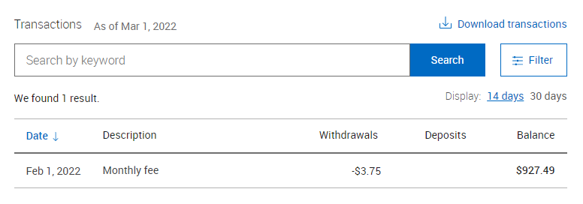
  - Fundraising (Short- and long-term revenue streams for the club), (Nate Kaye, Julien Rogers)

  - Events (League, Tournaments, Youth Engagement) (Micah Streeter, Nate Kaye, Julien Rogers)
    - Ice Bowl – Bump to next year
    - Putting League – Depends on School Board – on hold for now
    - Summer League – Peter Ask Julien
      - Start Date? Potential early June officially (Wed June 1st)
      - Town Agreement/Rental

  - Infrastructure (Peter Ewald, Dave Caplan, Micah Streeter)
    - Spring Course Clean Day / Move Baskets
      - Earlier May?
    - Signage
      - Sponsorship package
        - After we receive proposal from Fluent
        - Mock-up of Sign

  - Membership (Growth, By-Laws, Elections, social media (website and Instagram (Julien Rogers, Peter Ewald, Craig Nakamoto)
    - Memberships packages
    - Different levels – One with all the goodies and one basic.
      - One merch item
      - Bag Tag
      - Special CTP
      - Disc
      - minis
        - Nate talk to Ryan and Micah
        - Minimum 50?

      - Portage Promo – Peter to talk to owners
        - No pre orders – use special webpage
          - Hat
          - Toque
          - Shirt
          - Polo
          - Hoodie
- New Items/Other business:
  - Facebook group
    - Change name
    - Peter to check with Kevin

Last Meeting Notes/Items:
- Logo
  - Nate had a good response from his contact
    - Nate to follow up with ideas
    - With artist – because it’s a freebie – not a priority
      - Nate to follow up again
        - She is to busy
  - Use New proposed logo design #2
    - But Add ring around outside
    - Change lettering to Show Huntsville as Bigger
    - Add option to have name inside the logo

- Sponsorship
  - Nate to reach out to potential businesses
  - Bump to new year
    - $200 range for Tee Signs
      - $100-$500 range
    - Add to List
      - Record Shoppe
      - Sharpley’s
      - Sustain
      - Lakeland
      - Local
    - Pick this up next month
      - Website
      - QR code
      - Small Sign, Big Sign

- Clean up event
  - Early Spring Clean up date and move baskets

- Signage
  - Shorts and Longs
  - Separate Sign for Sponsor?
  - Drop Ace list
  - Work with Fluent
    - Hopeful Fluent will do some trading for work
      - i.e. Advertising
    - QR code.
  - Based on new layout
  - Peter Edit RFP - (Fluent)

