Huntsville Disc Golf Club
Board Meeting Minutes
February 1st, 2022
Invitees:
Nate Kaye
Micah Streeter - Absent
Scott Luttrell
Julien Rogers - Absent
Craig Nakamoto
Dave Caplan
Peter Ewald

Agenda:
- Review last meeting action items.
- Committee Updates
  - Finance (Peter Ewald, Craig Nakamoto, Micah Streeter, Dave Caplan) BALANCE = $931.24
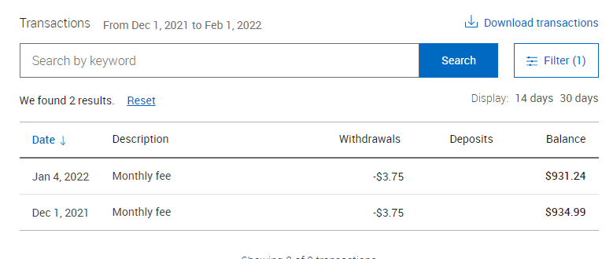
  - Fundraising (Short- and long-term revenue streams for the club), (Nate Kaye, Julien Rogers)
  - Events (League, Tournaments, Youth Engagement) (Micah Streeter, Nate Kaye, Julien Rogers)
    - Ice Bowl – Bump to next year
    - Putting League – Depends on School Board – on hold for now
    - Summer League – Peter Ask Julien
  - Infrastructure (Peter Ewald, Dave Caplan, Micah Streeter)
  - Membership (Growth, By-Laws, Elections, social media (website and Instagram (Julien Rogers, Peter Ewald, Craig Nakamoto)
- New Items:
  - Logo
  - Sponsorship
  - Signage
    - Course Layout confirmed on Site
    - RFP issued.
      - Question regarding “points”
  - Board Member attendance
  - Membership
  - Ice Bowl

Last Meeting Action Items:
- Logo
  - Nate had a good response from his contact
    - Nate to follow up with ideas
    - With artist – because it’s a freebie – not a priority
      - Nate to follow up again
        - She is to busy
  - Use New proposed logo design #2
    - But Add ring around outside
    - Change lettering to Show Huntsville as Bigger
    - Add option to have name inside the logo

- Sponsorship
  - Nate to reach out to potential businesses
  - Bump to new year
    - $200 range for Tee Signs
      - $100-$500 range
    - Add to List
      - Record Shoppe
      - Sharpley’s
      - Sustain
      - Lakeland
      - Local
    - Pick this up next month
      - Website
      - QR code
      - Small Sign, Big Sign

- Clean up event
  - Early Spring Clean up date and move baskets

- Signage
  - Shorts and Longs
  - Separate Sign for Sponsor
  - Drop Ace list
  - Work with Fluent
    - Hopeful Fluent will do some trading for work
      - i.e. Advertising
    - QR code.
  - Based on new layout
  - Peter Edit RFP - (Fluent)

Action Items:
- Peter - Book Walk Through
  - Coordinate with Kevin
  - Stake out new holes
- Peter – Contact Kate re Logo
- Peter – Ask Julien re: running league
- Nate – Start formulating plan for sponsorship

