Huntsville Disc Golf Club
Board Meeting Minutes
December 7th, 2021
Attendance:
Nate Kaye – Present
Micah Streeter – Absent
Scott Luttrell – Absent
Dave Cort – Absent
Tyler Smith – Absent
Julien Rogers – Present
Craig Nakamoto - Present
Dave Caplan – Present
Peter Ewald – Present

Agenda:
- Review last meeting action items.
  - See below
- Committee Updates
  - Finance (Peter Ewald, Craig Nakamoto, Micah Streeter, Dave Caplan)
    - Current Balance = $934.99
    - Peter to reach out to Town for invoice for rental fees – Amount = 325.44 PAID IN FULL (November 16th, 2021)
    - Peter to get update from Julien on income this year – Amount = $330.00 NOTE: Julian still has Ace Pot money and a Float
    - ODSA fees due – Affiliate Club needs to be updated. – Amount = $29.20
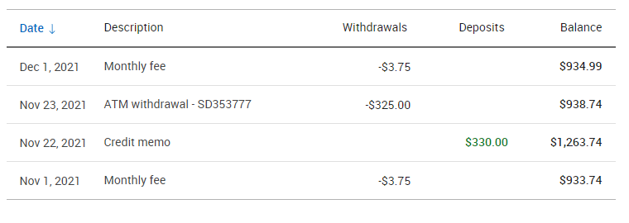
  - Fundraising (Short- and long-term revenue streams for the club), (Tyler Smith, Nate Kaye, Julien Rogers)
    - Town of Huntsville approved sponsorship, except beer/cannabis/tabaco etc. Time to start fundraising for these.
  - Events (League, Tournaments, Youth Engagement) (Micah Streeter, Nate Kaye, Julien Rogers, Dave Cort)
    - Indoor Putting League – Nate
    - Ice Bowl – Micah/Peter
      - Nate to help
  - Infrastructure (Peter Ewald, Dave Caplan, Micah Streeter)
    - Spring Clean Up date and new holes
  - Membership (Growth, By-Laws, Elections, social media (website and Instagram (Julien Rogers, Peter Ewald, Craig Nakamoto)
    - Need Logo. Do a big membership drive early next year
    - Board members to pay in new year

Last Meeting Action Items:
- Logo
  - Nate had a good response from his contact
    - Nate to follow up with ideas
    - With artist – because it’s a freebie – not a priority
      - Nate to follow up again

- Sponsorship
  - Nate to reach out to potential businesses
  - Bump to new year
    - $200 range for Tee Signs
      - $100-$500 range
    - Add to List
      - Record Shoppe
      - Sharpley’s
      - Sustain
      - Lakeland
      - Local

- Clean up event
  - Early Spring Clean up date and move baskets

- Signage
  - Start with Shorts only
  - Based on new layout
  - Use Peters rough template as starting point with vendors (Fluent)
  - Ace list?
    - Separate sign
  - Bump to new year – after layout confirmed

- Putting League
  - Confirmed Wednesday – 7-8 at Huntsville High School: Gym C
  - First one completed.
  - Nate sent questions to school board
  - Mask mandate on your way in and out, take off in gym
  - Vaccine proof
  - Attestation Form once
  - QR code screening every time
  - Dec 8th – All above 5 year of age need at least first shot

- Make options on course change
    - Hole 10
      - To 1B – Hold on this now until we see what happens with Pickleball
      - Or between 16/17
      - Or between 14/15 – requires more work.
        - Set up an onsite meeting
          - Facebook post – pick a date – Board
          - Sunday Morning @10am– This week -
    - Hole 6 – Good to go
    - Hole 11 – Good to go
  - Then take to a vote to the Board

Discussion/Action Items:
- Board Membership and attendance
  - 60% attendance?
  - Peter to message members with poor attendance
- Pickleball court and impacts on our course
  - Supposed to be a 10’ buffer from the stakes with blue paint and then 30’ to the court fence. It should be ok, but we have to just wait and see.
- Year end update
  - Financial
  - League summary
    - Julien to investigate
- Membership for 2022
  - See above
- Ice Bowl
  - See above
- Other items

NEXT MEETING – January 4th, 2021
Meeting Adjourned.

