Huntsville Disc Golf Club
Board Meeting Minutes
November 2nd, 2021
Attendance:
Nate Kaye – Present
Micah Streeter – Absent
Scott Luttrell – Absent
Dave Cort – Absent
Tyler Smith – Absent
Julien Rogers – Absent
Craig Nakamoto - Present
Dave Caplan – Present
Peter Ewald – Present

Agenda:
- Review last meeting action items.
  - See below
- Committee Updates
  - Finance (Peter Ewald, Craig Nakamoto, Micah Streeter, Dave Caplan)
    - Current Balance = $937.49
    - Peter to reach out to Town for invoice for rental fees
    - Peter to get update from Julien on income this year
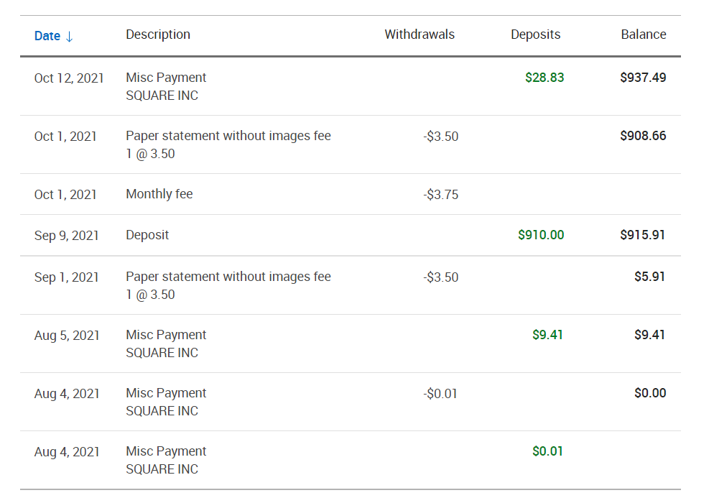
  - Fundraising (Short- and long-term revenue streams for the club), (Tyler Smith, Nate Kaye, Julien Rogers)
    - Town of Huntsville approved sponsorship, except beer/cannabis/tabaco etc. Time to start fundraising for these.
  - Events (League, Tournaments, Youth Engagement) (Micah Streeter, Nate Kaye, Julien Rogers, Dave Cort)
    - Year End Event – Dave held his
    - Indoor Putting League – Nate
  - Infrastructure (Peter Ewald, Dave Caplan, Micah Streeter)
    - Clean up day held October 17th – Very successful
    - Clean up day with power tools to be held November on 14th.
  - Membership (Growth, By-Laws, Elections, social media (website and Instagram (Julien Rogers, Peter Ewald, Craig Nakamoto)
    - Need Logo. Do a big membership drive early next year
Last Meeting Action Items:
- Peter to follow up with Micah on a course clean day
  - Propose October 17th
  - Peter to send email and update Facebook
- Start getting quotes for signage. Micah to gather information and Peter to send emails.
  - Fluent
  - TinLid
  - Nates source
  - Craigs Source
- Need logo for membership drive
  - Nate to reach out to his corporate logo developer
- Website set up for online payments
  - Membership – Put in email as well. Top of the home page.
  - League
  - Donation
- Putting League
  - Canvas Brewery
  - Wednesday nights
  - Commitment for money? Nate to explore
  - Nate to ask Canvas regarding Covid rules

Discussion/Action Items:
- Logo
  - Nate had a good response from his contact
    - Nate to follow up with ideas

- Sponsorship
  - Nate to reach out to potential businesses

- Clean up event
  - November 14th
    - Peter to reach out to Town for approval
    - Peter to create an event on the Facebook page

- Signage
  - Start with Shorts only
  - Based on new layout
  - Use Peters rough template as starting point with vendors (Fluent)
  - Ace list?
    - Separate sign

- Putting League
  - Canvas turned us down
  - Next option: School – Huntsville High School: Gym C
    - $25 per hour
    - Wednesday 7-8pm
    - Fully vaccinated
    - Mask Mandate

- Make options on course change
  - Then take to a vote to the Board
    - Hole 10
      - To 1B or 16/17
    - Hole 6
    - Hole 11
  - Peter to send an email to Board
  - Include Kevin

NEXT MEETING – December 7th, 2021
Meeting Adjourned.

